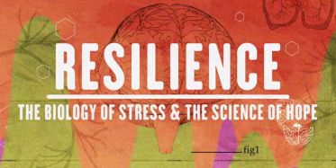

Resilience
Enhancing a Culture of Health by building resilience in our community
Free Documentary Screening & Panel Discussion

Wednesday, November 29, 2017
1pm
Care Oregon
315 SW 5th AVE
Portland, Oregon 97204

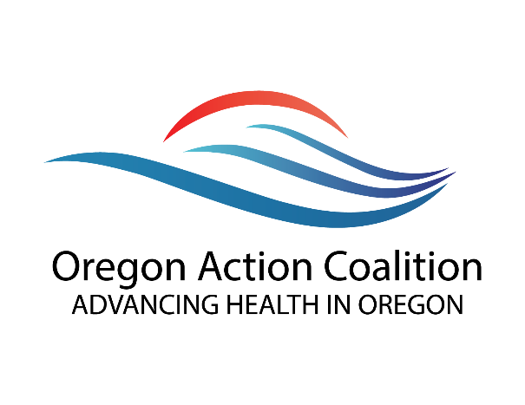
Resilience: The Biology of stress & the Science of Hope illustrates how parents, caregivers, educators, healthcare professionals and law enforcement can disrupt cycles of violence, addiction, and disease through establishing dedicated, nurturing relationships.

Sponsored by: Oregon Action Coalition
Hosted By: Care Oregon
Limited Seating: RSVP
http://bpt.me/3103896

