Improving Healthcare Through Nursing
Making a difference in Oregon
The Oregon Action Coalition is part of the Future of Nursing: Campaign for Action, a nationwide movement to improve health and health care through nursing. An initiative of AARP and the Robert Wood Johnson Foundation, the Campaign includes Action Coalitions in 50 states and the District of Columbia working to implement the Institute of Medicine’s Future of Nursing recommendations.
- Our nation faces pressing health care challenges—an aging and more diverse population with more chronic conditions, soaring costs, and a shortage of providers.
- We can meet these urgent challenges by maximizing the use of nurses to improve access to care, promote wellness, and lead system change.
- We are working to prepare the next generation of nurses to meet increasing demand, and position nurses to lead/manage system change.

To meet growing health care demands/challenges, we need to change how nurses are educated, trained, and practice.
Nursing must be ready to meet growing demands and lead change; this includes preparing nurses to practice in new ways and in different settings, with more diverse populations. We need:
- more nurses with bachelor and graduate degrees to manage increasingly complex health system challenges, in a range of settings (ambulatory, community, home) and to teach the next generation of nurses;
- all health care providers to practice to the full extent of their education and training; so we are working to remove outdated barriers that limit fully qualified nurses and others from expanding access to care;
- expanded nurse leadership to ensure that nurses have a voice on management teams, in board rooms, and during policy debates

Join us and help shape the future of health and health care for everyone in America.
The success of this effort will depend on the willingness of diverse stakeholders to come together to focus on health, expand access, improve quality, and contain costs
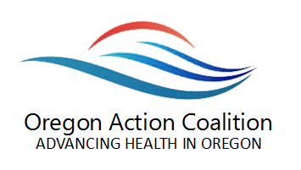
Get Connected
http://oregoncenterfornursing.org/partnerships/oregon-action-coalition/

 | www.twitter.com/Campaign4Action |  | www.facebook.com/CampaignForAction

