The Oregon Action Coalition promotes the Institute of Medicine recommendations for healthcare outlined in the 2010 Future of Nursing Report. It is an outgrowth of collaboration among nurse leaders from the Oregon Center for Nursing (OCN), Oregon Nursing Leadership Council (ONLC), Oregon Nurses Association (ONA), and the Northwest Organization of Nurse Executives (NWONE). (See History of Oregon's Nursing Leadership Groups below for a description and background of nursing leadership in Oregon.)

The OAC encompasses all eight of the IOM recommendations in its scope, with priority given to increasing the number of baccalaureate nurses and promoting nurses in leading healthcare change. The OAC is comprised of two Co-leads, one representing a nursing organization and one representing a non-nursing organization who sit on the 20 member Steering Committee. The current co-leads represent the Oregon Center for Nursing and the Oregon Patient Safety Commission. The Steering Committee has 12 dedicated positions and eight at-large positions, which may be filled by various stakeholders:

Position | Number
Graduate student | 1
Undergraduate student | 1
Rural | 1
Hospital or Health system | 1
Nursing school admin or faculty – OCD  (Oregon Council of Deans) | 1
Nursing school admin or faculty – OCAP  (Oregon Council of Associate Degree Programs) | 1
Nursing organization | 2
Non-nursing organization | 2
Practice | 2
At large | 8

Background
With the 2010 publication of IOM report, Oregon nursing leaders hosted a number of meetings with nurses across the state. These meetings were to determine which were the most important recommendations of the IOM/FON for Oregon. They also considered whether Oregon should become an official Action Coalition as part of the Robert Wood Johnson sponsored Campaign for Action which was intent on developing action coalitions in all states.

Meetings related to identification of the important elements of the IOM/FON recommendations were held during 2011 - 2013. Initially, recommendations focused on interdisciplinary education, engagement of physicians and other partners, support of residency programs for new nurses, and other groups that needed to be involved and in what way. In 2011, informal polling took place in which ONLC members chose as the first and second goals to be the 80% baccalaureate by 2020 goal, and building an infrastructure for workforce data. Guests in the meeting chose reducing practice barriers, expanding collaboration, and leading change to advance health. The issue of whether Oregon nursing leadership should become a regional action coalition (RAC) of the Robert Wood Johnson intent to see every state engaged in implementation of the IOM/FON report. The issue was raised but not resolved.
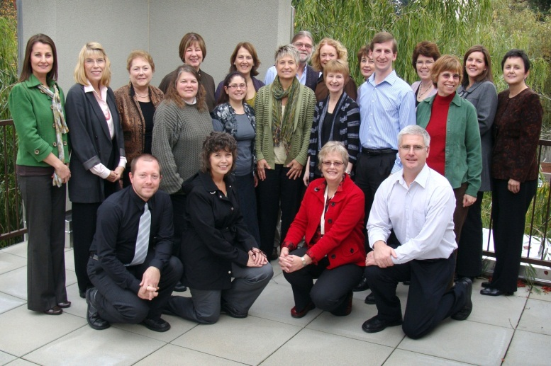
ONLC Left to Right —Back row: Ileana Ivan, Catherine Salveson, Janie Griffin, Gladys Campbell, Margo Halm, Tom Engle, Joanne Warner, Virginia Lundquist, Kay Carnegie, Christy Cowgill, Ruby Jason; middle row: Carol Thorn, Basilia Basin, Mary Rita Hurley, Ann Busch, Bret Lyman, Elaine Keavny; front row: Jake Creviston, Susan Thompson, Paula Gubrud, Larry Cheyne.
NURSE.com January 2012
However, in November of 2011, the Oregon Nursing Leadership Collaborative announced the formation of two workgroups dedicated to implementing changes recommended in the 2011 Institute of Medicine Future of Nursing report. One group focused on increasing the number of baccalaureate-educated nurses, and the other on preparing and enabling nurses to lead change. The groups were charged with developing action plans to affect the way nurses participate in healthcare transformation and provide care throughout Oregon.

Discussion continued regarding whether Oregon should become a regional action coalition of the Robert Wood Johnson intent to see every state engaged in implementation of the IOM/FON report. Initially, the assumption was that ONLC would "host" the IOM/FON work. However, consensus did not emerge on this proposal. Eventually, consensus was reached that the Oregon Center for Nursing (OCN) would partner with the newly-formed Oregon Action Coalition (OAC) (May 2012) which at the time was comprised of all the individuals interested in the IOM/FON work and included the Northwest Health Foundation as one of the co-leads, along with the Oregon Center for Nursing. OAC struggled early on and for various reasons, the work groups had to suspend their work due to external factors that had slowed progress and lack of funds to support a project related to the public perception of nurses/nursing.

During the Winter of 2012 the Oregon Action Coalition Co-Lead from the Oregon Center for Nursing (Mary Rita Hurley, Executive Director of the Oregon Center for Nursing and Jake Creviston, member of the Leadership Workgroup attended the National Future of Nursing Campaign for Action in Washington DC. Returning with renewed vigor and they inspired the OAC to move into the future. The OAC immediately began searching for, and found, a positive non-nursing Co-Lead, the Oregon Patient Safety Commission to replace the then vacant co-lead position. Keenly aware of their organizational struggles, in the Summer of 2013, the group reached out to Kristen Crusoe, Oregon Health & Science University nursing faculty, to take the Action Coalition through an Appreciative Inquiry process. Out of this work came a clearer mission, vision, and directional focus that would guide the operational phase of the Future of Nursing Action Coalition for many years into the future. The OAC re-organized, established leadership, and is actively engaged in moving its major priorities. ONLC continues its supporting role in a variety of ways.

Relationship of the OAC to the community, 2013
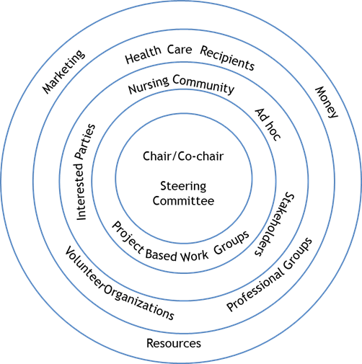

History of Oregon's Nursing Leadership Groups

Prepared by Sue B. Davidson, PhD, RN, CNS
Oregon Center for Nursing
July 17, 2014

The Oregon Nursing Leadership Council (ONLC) was formed when nursing leaders in the state became concerned over the looming shortage of nurses. In 1999, the Oregon Tri-Council (comprised of Oregon Nurses Association (ONA), Northwest Organization of Nurse Executives (NWONE), Oregon State Board of Nursing (OSBN), NLN-Oregon Affiliate (National League of Nursing), Oregon Association of Associate Degree Programs (OCAP) and deans of schools of nursing (OCD) began meeting to develop a plan to address the shortage. Several conferences were held to achieve consensus and create a master plan at the state level. The group transformed its purpose and focus and became known as the Oregon Nurses Leadership Council which was created to lead this work.

The ONLC members consisted of three representatives from each of the following groups: ONA, NWONE, OCAP, Oregon Council of Deans, with an ex officio member from the OSBN. The ONLC developed a comprehensive strategic plan using a consensus model. Two goals addressed changes needed in nursing education, two goals addressed work place/practice changes and the fifth goal addressed the need to establish a nursing workforce center.

In 2002, a subcommittee of the ONLC was established to address the strategic goal related to aligning nursing education curricula with emerging nursing practice and changes in health care. Through a year of dialogue and unprecedented collaboration, the Oregon Consortium of Nursing Education (OCNE) was created as one strategy to fulfill this strategic goal. The outcome of the OCNE consortium involved creating a competency based curriculum shared by community colleges and the Oregon Health & Science University (OHSU) School of Nursing (SON). The curriculum is a baccalaureate curriculum and allows community college students to earn an associate degree in nursing after completion of the first three years and provides opportunity for all consortium students to complete the baccalaureate degree in four years through a seamless system of education. Through funding from numerous grants and awards, the shared curriculum was developed between 2003 - 2006 and the first wave of schools launched implementation in 2006. OCNE currently has nine community college partners and includes the five campuses of OHSU SON. The partnership is sustained through a governing structure featuring collaborative leadership and a committee structure that supports curriculum, research and evaluation and education innovation.

In 2009, ONLC approved the formation and development of an OCN (Oregon Center for Nursing) to extend this work and in order to have a 501c3 entity that could continue work on the shortage. The Center has focused on workforce analysis in its early years as well as publishing various reports on nursing education, nursing practice, and other aspects of the shortage. (See Figure).
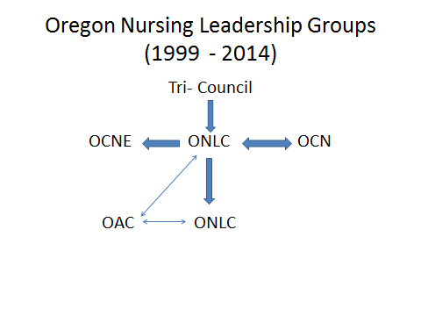

Abbreviations:

IOM/FON = Institute of Medicine/Future of Nursing
NLN = National League for Nursing
NWONE = Northwest Organization of Nurse Executives
OCAP = Oregon Consortium of Associate Programs
OCD = Oregon Council of Deans
OCN = Oregon Center for Nursing
OCNE = Oregon Consortium on Nursing Education
OHSU = Oregon Health & Science University
ONA = Oregon Nurses Association
ONLC = Oregon Nursing Leadership Council
OSBN = Oregon State Board of Nursing
RAC = Regional Action Coalition

In 2008 the RWJF approached with IOM to partner in assessing the needs of American healthcare, and how nurses and the nursing profession can meet that need. In 2010 the RWJF and IOM released the Future of Nursing report, as a blueprint for the needs of Americans, and how to improve nursing to address those needs. To implement the report’s recommendations, RWJF sought out the guidance and expertise of AARP, forming the Campaign for Action. The Campaign for action sponsored the organization of State-level action coalitions, bringing together nurses and community and healthcare stakeholders within every state and the District of Columbia.
Oregon Center for Nursing (OCN), Oregon Nurses Association (ONA) Oregon Nursing Leadership Council (ONLC), and Organization of Nurse Executives (NWONE)

