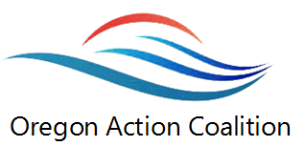
Culture of Health
Adverse Childhood Events

In support of the Robert Wood Johnson Culture of Health initiative, the Oregon Action Coalition is focusing on communicating to and educating Oregonians about the effect of adverse childhood events.

Three upcoming events will provide you with an opportunity to learn more:

- Attend the Oregon Public Health Association presentation on 10/9/17 at ___________________________
- Join us for a screening of __________________ on 11/29/17 at 1 pm at Care Oregon _______________________________
- Participate in continuing education through the ONA learning management system at www._____________________

